**Homework Running Boxes**

1. **Image Slider**
2. **Screenshot**

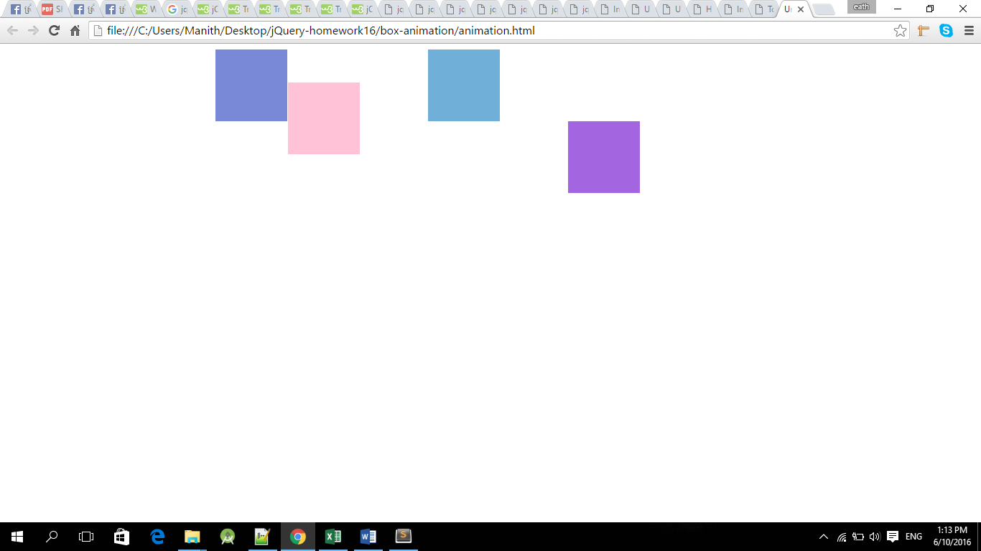

1. **Objective**

After doing this homework, student can create running boxes animation.

1. **Deadline**

* Start Date: 10/June/2016
* Collection date: 16/June/2016

1. **Instruction**

Using animate() with CSS property, using callback function.

1. **Marking Criteria**

* Correctness: 80%
* Code Arrangement: 20%